University Of Engineering and Technology, Lahore
Computer Engineering Department

Course Name: Programming Fundamentals | Course Code: CMPE-112L
Assignment Type: Lab Report | Dated:
Semester: 1st | Session: 2026 Spring
Lab/Project/Assignment #: 1 | CLOs to be covered: CLO
Lab Title: While Loop | Teacher Name: Hafiz Muhammad Mubashar
Lab Evaluation:

CLO1 | Apply appropriate programming techniques to create executable programs to solve well defined problems
 | Level1 | Level2 | Level3 | Level4 | Level5 | Level6
(5)
Total |  |  |  |  |  | /5
Rubrics for Current Lab Evaluation
Scale | Marks | Level | Rubric
Excellent | 5 | L1 | Submitted all lab tasks, BONUS task, have good understanding.
Very Good | 4 | L2 | Submitted the lab tasks but have good understanding
Good | 3 | L3 | Submitted the lab tasks but have weak understanding.
Basic | 2 | L4 | Submitted the lab tasks but have no understanding.
Barely Acceptable | 1 | L5 | Submitted only one lab task.
Not Acceptable | 0 | L6 | Did not attempt
LAB No 1
Lab Goals/Objectives:
• Understand the concept of While loops.
• Learn to repeat tasks using loops.

Equipment Required:
• Computer/Laptop
• Python 3.x
• IDE (IDLE, VS Code, or PyCharm)

Theory:

A while loop repeatedly executes a block of code as long as a given condition is True. It is useful when the number of iterations is not known in advance.

Lab Work:

While Loop:
Task 1:
i = 1
while i <= 5:
print(i)
i += 1

Result:

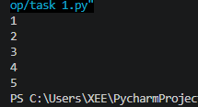

Task 2

total = 0
i = 1
while i <= 10:
total += i
i += 1
print("Sum =", total)

Result:

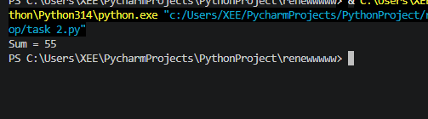

Task 3:

y=int(input("enter number of students"))
i=1
while (i<=y):
n=input("enter your name")
a=int(input("enter obtained marks"))
b=int(input("enter total marks"))
c=a/b*100
print(c)
if c>=90:
print("A")
elif c>=85:
print("A-")
elif c>=80:
print("B+")
elif c>=75:
print("B-")
elif c>=70:
print("C+")
elif c>=65:
print("C-")
elif c>=60:
print("D+")
elif c>=55:
print("D-")
else :
print("F")
i=i+1

Result:

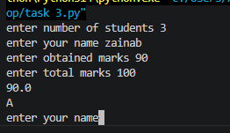

Task 4:
y=int(input("enter number of students"))
i=0
while (i<=50):
n=input("enter your name")
a=int(input("enter obtained marks"))
b=int(input("enter total marks"))
c=a/b*100
print(c)
if c>=90:
print("A")
elif c>=85:
print("A-")
elif c>=80:
print("B+")
elif c>=75:
print("B-")
elif c>=70:
print("C+")
elif c>=65:
print("C-")
elif c>=60:
print("D+")
elif c>=55:
print("D-")
else :
print("F")
i=i+1

Result:

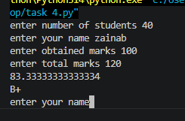

Conclusions:

In this lab, we learned how to use while loops to perform repetitive tasks based on a condition. We also understood how proper loop conditions help control program execution and prevent infinite loops.

